
Sexual Harassment of Women in Colleges and Universities: Concerns and Solutions

Report

16thNovember 2017

Library Conference Hall, TISS, Mumbai
Women Power Connect – Tata Institute of Social Sciences, Mumbai – Friedrich Ebert Stiftung




Introduction

The Genderlogue entitled “Sexual Harassment of Women in Colleges and Universities: Concerns and Solutions” was envisaged as a means to initiate dialogue between internal committee members / the college administration and the concerned students. In the light of growing dissatisfaction with the slow and tedious process involved in filing a complaint with an ICC, the Genderlogue aimed to discuss solutions whereby justice is made possible for aggrieved women without compromising on the rights of the respondent.
This Genderlogue attempted to deliberate on following points:
- An Overview: The situation of sexual harassment at campuses in Mumbai.
- Challenges of functioning of ICs and suggestions to address them.
- Male students and students of third gender under the purview of redressal system.
- Measures taken for building a gender sensitive TISS community and the redressal mechanism at TISS.
- Issues and concerns of female students.
- A way forward.
In the aftermath of the Nirbhaya incident of December 12th, 2012 UGC constituted a Task Force, in order to assess the situation of safety of women and youth in general at university campuses and colleges across India. In December 2013, the Task Force came out with a report entitled, “Saksham— Measures for Ensuring the Safety of Women and Programmes for Gender Sensitization on Campuses”. The report emphasized that lack of gender sensitivity among students, faculty in all disciplines, support staff and administration continues to be a serious concern in higher education institutions of the country. There is a culture of silence and lack of clarity on the issue of discrimination and harassment. Further, it was observed that there is a problem of protectionism in colleges, wherein, colleges and universities have policies that require women to adhere to strict hostel norms, restrictions on the movements of women students, intake forms that require information pertaining to marital status of women students, or other means whereby women are restricted from participating in academics and other aspects of college life. The report also underscores the importance of alternative civic redressal system for responding to the issue of sexual harassment in the higher education institutions.
The task force recommended several measures including setting up of a gender sensitization unit within UGC; gender sensitization training for all the members of higher educational institutions and including a gender audit component in the evaluation process of the NAAC for its assessment and accreditation procedures.
On 2nd May 2016, Ministry of Human Resource Development (University Grant Commission) notified University Grants Commission (Prevention, Prohibition and Redressal of Sexual Harassment of Women Employees and Students in Higher Educational Institutions) Regulations, 2015. The document entails responsibilities of educational institutions, grievance redressal mechanism, and process for making complaint and conducting inquiry, interim redressal, punishment and compensation, and consequences of non-compliance. It is important to underscore that the UGC Regulations 2015 direct all higher education institutions to “act decisively against all gender based violence perpetuated against employees and students of all sexes recognizing that primarily women employees and students and some male students and students of the third gender are vulnerable to many forms of sexual harassment and humiliation and exploitation”, making space for male students and students of third gender to lodge complaints against sexual harassment faced by them.
The GenderLogue was moderated by Dr. Bindhulakshmi, Associate Professor, Advanced Centre for Women’s Studies who provided background of the event in terms of global impact of mind boggling revelations made by “Me Too” and national discourse as a result of “Him Too” campaigns on social media.
Ms. Damyanty Shreedharan, Senior Programme Officer of FES provided the genesis of GenderLogue on Women and Work, Violence against Women, Political Feminism in different parts of India over last one decade.
Ms. Gayatri Sharma, Director, WPC introduced activities of WomenPowerConnect in terms of networking, research, lobbying on gender concerns.
Prof. R.Ramakumar, Dean, School of Development Studies, TISS
Despite being one of the most vibrant centres in the universities, Centres for Women’s Studies in colleges and university spaces are not receiving policy friendly responses and support especially in terms of funding and job-security. In this context, it is challenging for the centre to sustain their activities within the university spaces.
Recent disclosure of the list of scholars allegedly involved in sexual assault incidences has been an important wake up call for the administration of the universities and colleges that are responsible for addressing the complaints on sexual harassment. It has also created new space for a discussion in women’s studies.
It is important to understand that there is no undermining of the due process. However, it is also crucial to state that the principle of natural justice has not built confidence among women and girls. Girls and women in academic institutions continue to feel vulnerable and believe that their complaints have not been addressed adequately. Many a times the system has been biased against them and their complaints have not reached any logical conclusion. Therefore, urgent measures are needed to be taken to address the gaps and to ensure that confidence and trust is built among women in academia that universities and colleges are safe spaces.
While one would not completely agree with all the aspects of recent events followed by the disclosure of the list, however, one still believes that this moment has a great democratic potential in making campuses safe spaces.
Lot of times men in academia do not appreciate as to what constitutes sexual harassment. Several at times, male faculties send messages to female students late night with no particular sexual content. When that persists for longer time, student approaches the committee. When the committee confronts the faculty, it takes several sittings with the concerned faculty to make them realize that their actions were inappropriate. There may be genuine cases and gray areas; however, it is precisely for this reason that we do need awareness programmes to clearly reinstate as to what is acceptable and what is unacceptable behavior.
There is a simple rule that when a male faculty is having a meeting with female student in their room, the door of the room should remain open. However, many faculty members do not follow this just because they do not appreciate the importance of it. Therefore, it is extremely essential to have programmes for both male and female members in academia to make them acquainted on the importance of this issue, different dimensions it has and how to respond at individual and institutional level.
Prof. Vibhuti Patel
Chairperson, Advanced Centre for Women’s Studies, School of Development Studies, TISS
Before Vishakha judgment, in Mumbai University and colleges, most of the incidents of the sexual harassment at the workplace, were reported by the women contract teachers and women contractual staff. They approached women’s rights organizations with their complaints. Students and teachers who faced sexual harassment approached Bombay University and College Teachers’ Association (BUCTU).
In response to Vishakha Directive, BUCTU organized a seminar, several college and university teachers, UG & PG students and M. Phil. /Ph.D. scholars shared their testimonies of sexual harassment and abuse. BUCTU also lobbied for formulation of Women Development Policy with twin objective of grievance redressal in case of sexual harassment and sustained gender sensitisation. This resulted in a few changes at the institutional level. For instance, whenever students were to be sent for the field work, internships or outside the colleges, they were sent in groups accompanied by a woman faculty. The entire issue of sexual harassment was seen from the perspective of “moral turpitude”.
The criminal procedures used by the students and faculty were the section 354 (obscene behavior and outraging modesty) and the section 509 (insult the modesty of a woman), wherein it was discretion of police officers as to how they interpreted obscenity or outranging modesty. However, the response of police to these cases was shoddier. In several cases, police officials mediated by asking girls to tie a rakhi to boys.
Several cases were reported in the nursing colleges and hospitals of the South Bombay. A code of conduct was recommended to address the issue by Nurses Union.
King Edward Memorial (KEM) hospital and JJ hospital commissioned a study of sexual harassment faced by the students in the medical colleges which was supported by the Maharashtra State Commission of Women and conducted by Research Centre for women’s Studies, SNDT Women’s University, Mumbai. This study was important in terms of bringing new procedures and new code of conduct in the medical colleges.
Even after Vishakha directive 1997, teachers union had to pressurize the universities authorities to come up with Women Development Cell at college levels. Finally, in 2002, the Management Council of Mumbai University passed the resolution and 750 colleges under the jurisdiction of Mumbai University had Women Development Cells. The WDCs had a twin objective of gender sensitization and grievance redressal. There were more than 216 women teachers, staff and students who approached the University level WDC within two years of setting up Women Development Cells. However, women were reluctant to give their complaints in writing. Only one staff of university of department, group of teachers from 2 colleges, temporary teacher of a college and 2 research scholars gave their written complaints during 2002-2004. Still the WDC acted on women’s verbal complaint by reporting to the Vice Chancellor and tried to get immediate relief for the complainant.
When series of workshop classes were started with the cluster of colleges, several misogynistic misconceptions among participants were addressed. Both students and teachers made statements such as “there is no smoke without fire”, “man is a hunter and a woman is a prey”, “Women secretly enjoy the attention they get from the males when they pass comments on their bodies” , and “Women’s ‘No’ means ‘YES’”. It was also believed that women lacked sense of humor if they complained to the committees.
There was procedural training for the office bearers of the Women Development Cell. Saksham report has recommendations on gender sensitization. University Grants Commission, Ministry of Human Resource Development and Ministry of Home Department, Government of Maharashtra ask for quarterly reports on the activities conducted by the colleges in regard to the issue of sexual harassment and gender sensitization.
When we see the last twenty years of work on sexual harassment (1997-2017), there has been complete exhaustion and erosion of faith in “due process” on the part of survivors of sexual harassment. In a case of one engineering college, there were several complaints against one faculty. However, women development cell refused to take any measure. As a result many women students started dropping out of the classes, and students who stayed performed poorly because of the stress of continued verbal sexual abuse in the class by teacher. It was only after the external expert belonging to a woman rights organization insisted that an action should be taken, Women Development Cell of the college took the complaints seriously.
Whenever, there are complaints registered against the male faculty, responses from the colleagues are not forthcoming. Often they empathize with the person against whom the complaint has been filed in these words, “Poor thing, he got caught (sic)!” It is discouraging when people at the highest authority, who have been given the responsibility to make sure that the sexual harassment at the workplace Act, 2013 (SHW Act, 2013) is implemented, lack sensitivity, do not take the reported cases seriously and undermine the law and its due procedures. In this context, then what can students and women faculty really do? Even when the accused is punished, woman continues to face discrimination from various quarters. She is marked as a ‘”trouble maker” and her entire image is eroticized for the rest of her career. There is tremendous psychological trauma that women undergo, while the men accused comes out unscathed in terms of social acceptance. The office environment is often hostile to a woman complainant. However, it is important to have a discussion on the issue of “due process” and its limitations in a non-threatening environment.
Also, in the context of the ethics of dissertation-supervision for Master’s degree / M.Phil. / Ph.D. where teachers have unilateral power in terms of making or breaking a career of the students needs a serious examination.
Dr. Chayanika Shah, Forum against Oppression of Women, Mumbai
Dr. Chayanika Shah referred to the hierarchical nature of the SHW Act, 2013 which limits the role of the ICC to providing recommendations. The members are often nominated and not elected. This leaves a great deal of power to the employer. The Act mirrors hierarchies that exist in reality in campuses across India. The faculty has responsibility for students, which needs to be realized. A fine balance needs to be struck between the responsibility of faculty members to their students, and exertion of power and dominance.
Earlier, universities and colleges were accessible to upper caste and upper class males. Gradually, people from other marginalized identities started accessing these spaces. However, process and mechanism within the universities and colleges continue to maintain hierarchical relationships and are discriminatory in nature.
Admission of other marginalized identities to universities cannot be the only way towards inclusion. The question remains as how to initiate processes for equality and justice in the universities which are inherently discriminatory spaces?
Further, universities and colleges are perceived as safe spaces, wherein, young adults have privilege and leisure to explore and understand their self. However, people are taken aback when they experience discrimination within these spaces.
Moreover, there is an intimacy of classroom, intimacy created due to peer interactions, living in the hostels and campuses. Also, there is an intimacy in teachers-students interactions. There is a great imbalance of power within teacher-student relationship. Teachers and faculty do not reflect on the nature of power they execute. Moreover, universities do not offer spaces where conversations on it could be initiated and mechanisms where they could be collective learning on this.
In order to make universities and colleges non-discriminatory, several measures needs to be taken. For instance, existing pedagogies, curriculum, evaluation methods, and power hierarchy within the university needs to be examined. Unless there are processes and mechanisms wherein conversations on such issues could be initiated and held safely, nothing much could be achieved by establishing committees.
It is within this context, the deliberation on sexual harassment needs to be located. Establishing Internal Committees (with its flaws and limitations) is one of the processes for creating safe spaces. Instead of relying entirely on the institutional mechanisms, alternative processes such as student solidarities across the differences in responding to sexual harassment in the colleges could be envisaged. It is also crucial to pause and think as to much how much of democratization we practice in each and every interaction within the universities.
The responsibility of making universities and colleges a safe space is that of administration. By taking action irrespective of how important the faculty is to the university/college, the administration ensures that an environment of trust and confidence is built among students and others. ICs cannot work in isolation as they need the support and confidence of students, faculty and staff of the universities. Solidarities among the margins are needed to make authorities responsible for their work. There is a need to have larger representation of marginalized identities in the committees. Faculty should take a sincere interest in the workshops held on sexual harassment.
On the issue of the list been made public, there has been a shift in debate. Earlier victims were being named and marked, but with the list it is the marking and naming of men. With this list, mirror has been shown to us as to how the due processes are working in the universities and colleges spaces.
Dr. Shewli Kumar, Chairperson, Gender Amity Committee, TISS Mumbai
Gender Amity Committee has been handling 10-15 cases every year. Each and every case has presented itself as unique and challenging for the committee. As TISS is a small and a deemed university, the committee has been able to use this to its advantage by having flexible processes in place. However, there has been a great amount of surveillance from the outside world. Therefore the working of the committee should be seen in the context where the university is embedded in the larger system outside and the larger changes that are happening in the world. The committee is part of this continuum and does not function in isolation.
In a particular case, a foreign exchange student who was harassed by the project staff, did not complain for a long time as she thought it is okay for Indian men to act in this way and it is in Indian culture. Also, there the committee countered the stereotype that it is okay to prey upon women from abroad. Further, while the committee wanted the complaint to lodge a police complaint, she was leaving India and did not want to go through this process. Therefore lot of onus lies on the complainant.
There is an entire supportive role that ICC has to play which is time consuming. Even after supporting the complainant at every stage, if the woman decides that she does not want to go further, then ICC has to support her in the decision.
The committee has received several complaints on intimate partner violence among students. Male students have been found to have multiple relationships and when female student decides that she does not want to be part of this relationship and tries to move out, she is harassed by the male partner through threats, intimidation and violence. These complaints are also reported several days, even months after they occur.
One of the limitations with ICC is that the committee is restricted to handling of the cases. However, the challenge is that girls and women on the campus do not trust or have confidence to approach ICC with their complaints. Here, the student representatives play an important role in building confidence among students that they can approach the committees with their complaints. Especially, with the cases of intimate partner violence among students, the student representatives have a greater role. Engagement with the incidents of intimate partner violence, has given insights to the deep embeddiness of gender, sexuality and power. It has elucidated clearly that there is a great need for every student and faculty on the campus to undergo gender curriculum to build an understanding on the issue. The committee is struggling in getting the faculty on board. It is crucial to have the active participation of the faculty as they will be able to translate it through their classroom interactions.
In one particular case, ICC had to deal with political interference and backing that accused received. The recommendatory nature of the ICCs is the major challenge in the functioning of the committees. It is the limitation of the law itself. The due process written in the law is also very limited. It does not specify the qualifications and experience of the individuals who would inhabit ICCs. What kind of the gender related activities the potential committee members should have undertaken before qualifying as ICC member? Also, what are the roles of student representatives? The act is very constraining in terms of actual functioning of the ICCs.
Even though notifications have been issued that the anonymous complaints shall not be entertained, however, few complaints have been received by the university administration. This reflects that there have been certain gaps in confidence and trust with the ICC among students. It is the challenge for the ICCs. In few instances, ICC was not able to take any action as the anonymous complaints did not get translated to written complaints as stated by the law. Students experience great amount of trauma in writing their statements. They much rather come and talk about it. They are also fearful about it getting public and losing confidentiality. Despite of several gender workshops, the environment for complainants remains hostile.
Often, Gender Amity Committee becomes the least important committee in the campus. There is less visibility, minimal resources, no staff and no infrastructure for the committee.
ICC has conducted session on gender non-normative. While the law is for women, but the ICC with the support of queer collectives managed to go beyond the brief. Resource centre for interventions on violence against women. Students are sent to do police complaints and they support women to do FIR.
The ICC has been able to rusticate and debarred people from the campus. Along with this the committee has referred complainants for counseling and support. Sometimes, women have gained confidence just by going for the counseling and have been able to stand up for themselves in ending the abuse. ICC at TISS have conducted orientation programs, developed new format for complaints, held workshop, file shows and discussion forums on gender, caste, religion. The committee has also developed Summary of Practice for ICC. There is a Gender ki Baatein boxes that are located at different places in the campus. Gender Amity Committee is in the process of developing gender policy for TISS.
Innovations and multiple strategies are required to engage with different constituencies on the issue. A continuous dialogue on the issue is required in order to move forward. There is a need to create supportive environment for women and people with non-normative behavior and expressions and at the same time there is need to establish concrete mechanisms for continuous knowledge creation. There is a need to have some serious introspection by each and every stakeholder. Getting faculty on board is a challenge for everyone and it should not be just ICC’s responsibility.
Ms. Geetarani, Student member of Gender Amity Committee, TISS (Mumbai)
The issues and concerns of female students and students belonging to gender minorities are massive and varied. Due to varied patriarchal ideas and gender socialization, even after considerable amount of work and effort, achieving an environment of safety, gender sensitization and zero tolerance towards sexual harassment and gender based violence is challenging in the universities spaces.
One of the major issues faced by the victim is lack of confidence. It has been found that though Internal Committees (ICs) receive several unofficial complaints, however, the victims are reluctant to file an official complaint even after several meetings with ICs. Fear of negative outfall on the victim and long process of hearing with the internal committees are cited to be few of the several reasons for not lodging an official complaint.
Second issue is that of reliving the trauma of the incident by victims during the due process. In the past, victims have shared that they want to get over with the entire proceedings as soon as possible as it keeps on reminding them of the incident of harassment.
The third major concern has been the tendency of victim blaming by society. Approaching the redressal institutions with the complaint takes great amount of personal courage. However, victim blaming and non-supportive environment deters people not to approach the ICs. The problem becomes acute for the victim who is a dalit, tribal or from a different race.
The fourth issue is that of prevalence of intimate partner violence among the students in the colleges. In several such cases victims do approach the committees, however, are reluctant to file an official complaint.
Fifth concern is that of safety of a victim after she files a complaint. Even when there are mechanisms ensuring safety of the student within the institute, it does not ensure safety outside the institute.
Sixth concern is the impact of the sexual harassment and the aftermath on the mental well-being of the victim. During several counseling sessions with the victims, it has been found that they often nurture a sense of guilt. Often their friends, colleagues and others make them feel that they have caused a great harm to another person by filing a complaint against them. There a long term implications, such as trust issues, loss of confidence in public spaces, fear of being labeled and several other psychological problems.
The mechanism of ICs needs to be strengthened. There is a need of strong commitment from the administration to strengthen the institutional mechanisms. Recommendatory nature of the ICs is a problem. Lack of proper budget, physical space, dedicated full time worker are some of the several limitations and challenges that restricts ICs from reaching out much more effectively.
There are few questions that need to be revisited as to what does justice actually mean to the victim? Is it lawful punishment being given to the perpetrators? What should be done to ensure the justice is served in its truest sense?
Discussion
- It is very important to discuss the fear of being labeled or being marked that a person who has experienced harassment or discrimination goes through. Speaking out for girls in a regular classroom environment or in academic discussion is quite challenging. Girls are expected to be quite even in public spaces. Speaking out becomes more oppressive when a girl/woman goes through harassment. Also, the acceptance of obscene jokes among peer group and to think it is “cool” to do so it quite unnerving. The offender has absolutely no clue that the act is offensive while the person who is on the receiving end does not know how to respond to it.
- There should be more coordination between Women Development Cell of universities and colleges. Teachers and students would be encouraged if they receive regular gender workshops and trainings on the issue of sexual harassment at workplace.
- How does CASH address the case of sexual harassment when the accused is a high profile person/faculty at the campus? They seem to have very little accountability with regard to the system because they are considered to be assets to the universities and colleges. In these cases, what responsibility or role the CASH has? Statement like people in academics or men in academics do not appreciate what constitutes as sexual harassment in a sense defends the powerful men in academia. In this context what position or action ICC can take and where then teachers union’s role and students union’s role come in?
- It is perceived that the Gender Amity Committee is offering a service to student community who are floating population. Whereas, teachers in a way are a static population. It is really important to discuss as to why there is a resistance from the faculty community to get involved in the gender trainings and be part of the ongoing discussion on sexual harassment. Why is that that there is lot of interest and participation by faculty for other refresher courses and trainings, however, not on the issue of gender and sexual harassment? In this context, sometimes, mandatory institutional processes are important as voluntary participation by the male faculty and others is clearly lacking.
- At first, it is important for students, the largest population in every college, to come together and verbalize their support to ICC. The position of ICC strengthens when it gets the support of the students. The committee is then able to lobby effectively to the higher authorities. The law does not give that negotiating power to the committee. Secondly, it is the responsibility of ICC to take their work beyond the brief laid out in the law. Law also states gender awareness, workshops and creating supportive environment. However, these processes are clearly missed out by ICCs.
- Chayanika Shah: How does the system respond when a powerful person is being accused? Whether it works for the person or against it is the real test of the system. By so far, there has been no case that has shown that the institutional processes could hold powerful accused accountable for their actions. Even in the cases where ICCs have given recommendations against accused, however, the universities have not acted upon them. There have been instances, where the principals have been suspended, however the power of the principal has not been taken away and they are still sitting in their offices without being shamed. The point that the principal was found guilty was also because the ICC was located not in the college but in the university. The pressure was created to remove that principal but it still did not shame him. In this context, what does the justice actually means? So we can tell them you have been found guilty but that guilt has to be felt as well. None of us are able to that to people we hold in high esteem. Even if we may agree that the people who have been named on the list, could possibly the offenders, however, we are not actually standing against them stating that we won’t be party to reinstating that position of authority for that person. This is a difficult task which colleagues have to do. It is not easy, especially for those feminist teachers from whom we are expecting it from. The people who are actually standing up for this politics are named and marked for different reasons. They are vulnerable and powerful in their own way. They will have to use the power they have to become even more vulnerable. If we are not able to voice our discomfit even when they have been found guilty then it is very far away to express our discomfort when they have not been found guilty. What should be our attitude towards these people is what we should start talking about. At least in the situations where it has been proved and convictions have been made, what is our process of shaming and taking authority from that person?
- How many vice-chancellors gender sensitization trainings have been conducted? We do not have gender sensitization programs for the people at the higher level of authorities. People in power are not taking interest in the issue.
- The absence of the male faculty at this discussion is quite telling of the lack of interest and importance the issue holds for them.
- Even if there are two or more committees set up to address the issue, the committees would not be effective till they get the support of the students. Students and committees have to work together to strengthen the process rather than disbanding the committee.
- Within the university setup, what kinds of work or pressure feminist faculty have garnered to put focus on sexual harassment within colleges? As feminist have we succeeded in adopting pedagogies that emancipating?
- University is already organized in hierarchical power structure. Unless that power structure is broken through various ways, there is a deadlock and the entire responsibility is put CASH and ICCs. Though there are institutional mechanisms, however, there are several measures that need to be taken collectively by the student and faculty community in order to really address the issue in hand. One of the ways is to think how to have solidarities despite our differences.
- The recent debates on Raya Sarkar coming public with the list of faculty alleged to have committed sexual harassment, had completely polarized the issue with shaming versus due processes, which completely lost the focus of the issue itself. When it comes to due process, the recent incident of Banaras University, wherein students had to take to streets and yet justice was denied really shows the loopholes within the institutional process. When putting one’s concern over due process, if one is accused of promoting vigilantism, how then safe spaces wherein discussion could be held

- Chayanika Shah: The institutional mechanism was set up because we believed that everyone does not have that space or support and the more marginalized a person is more vulnerable to harassment and less support the person has. The institutional processes have been for more than fifteen years acting in some manner. Maybe we all have put our hopes at ICC, and one of the obvious things that we have learned from the recent events is that it is not the way to go. Along with ICCs there are several strategies that need to be implemented. An institutional mechanism for redressal is only one the several measures. How do we have real conversations and not sensitizations, on issues of hierarchies within the universities? We have to actively think how to have conversations on our prejudices and blindness. And, the onus of that is clearly on ‘stable’ population, i.e., faculty. Students and contractual staff are vulnerable in the university context. We have to challenge the academia from within a sociological critique of class, caste, disability, queerness and gender. These are complex relationships and simple solutions such as keeping the door open when a female student is in a room, not sending her messages will not work. Honest conversations in classrooms, in university spaces between faculty and students and among students are important, which are not happening. The teachers and teacher’s union is primarily responsible for it, but also everyone else. These are deep misogyny deeply entrenched in us, in our systems and in our institutions which will not go soon.

After 3 hours of serious conversations in the GenderLogue, Shri. Vishal Kamble, Research Assistant, Advanced Centre for Women’s Studies, School of Development Studies, TISS, Mumbai offered Vote of Thanks to Prof. Parasuraman-Director TISS, Prof. Ramakumar-Dean of School of Development Studies of TISS, Smt. Damyanty Shreedhar of Freidrich Ebert Stiftung-Delhi, Ms. Gayatri Sharma-Director of WomenPowerConnect- Delhi, the panelists, the participants and the TISS administration.

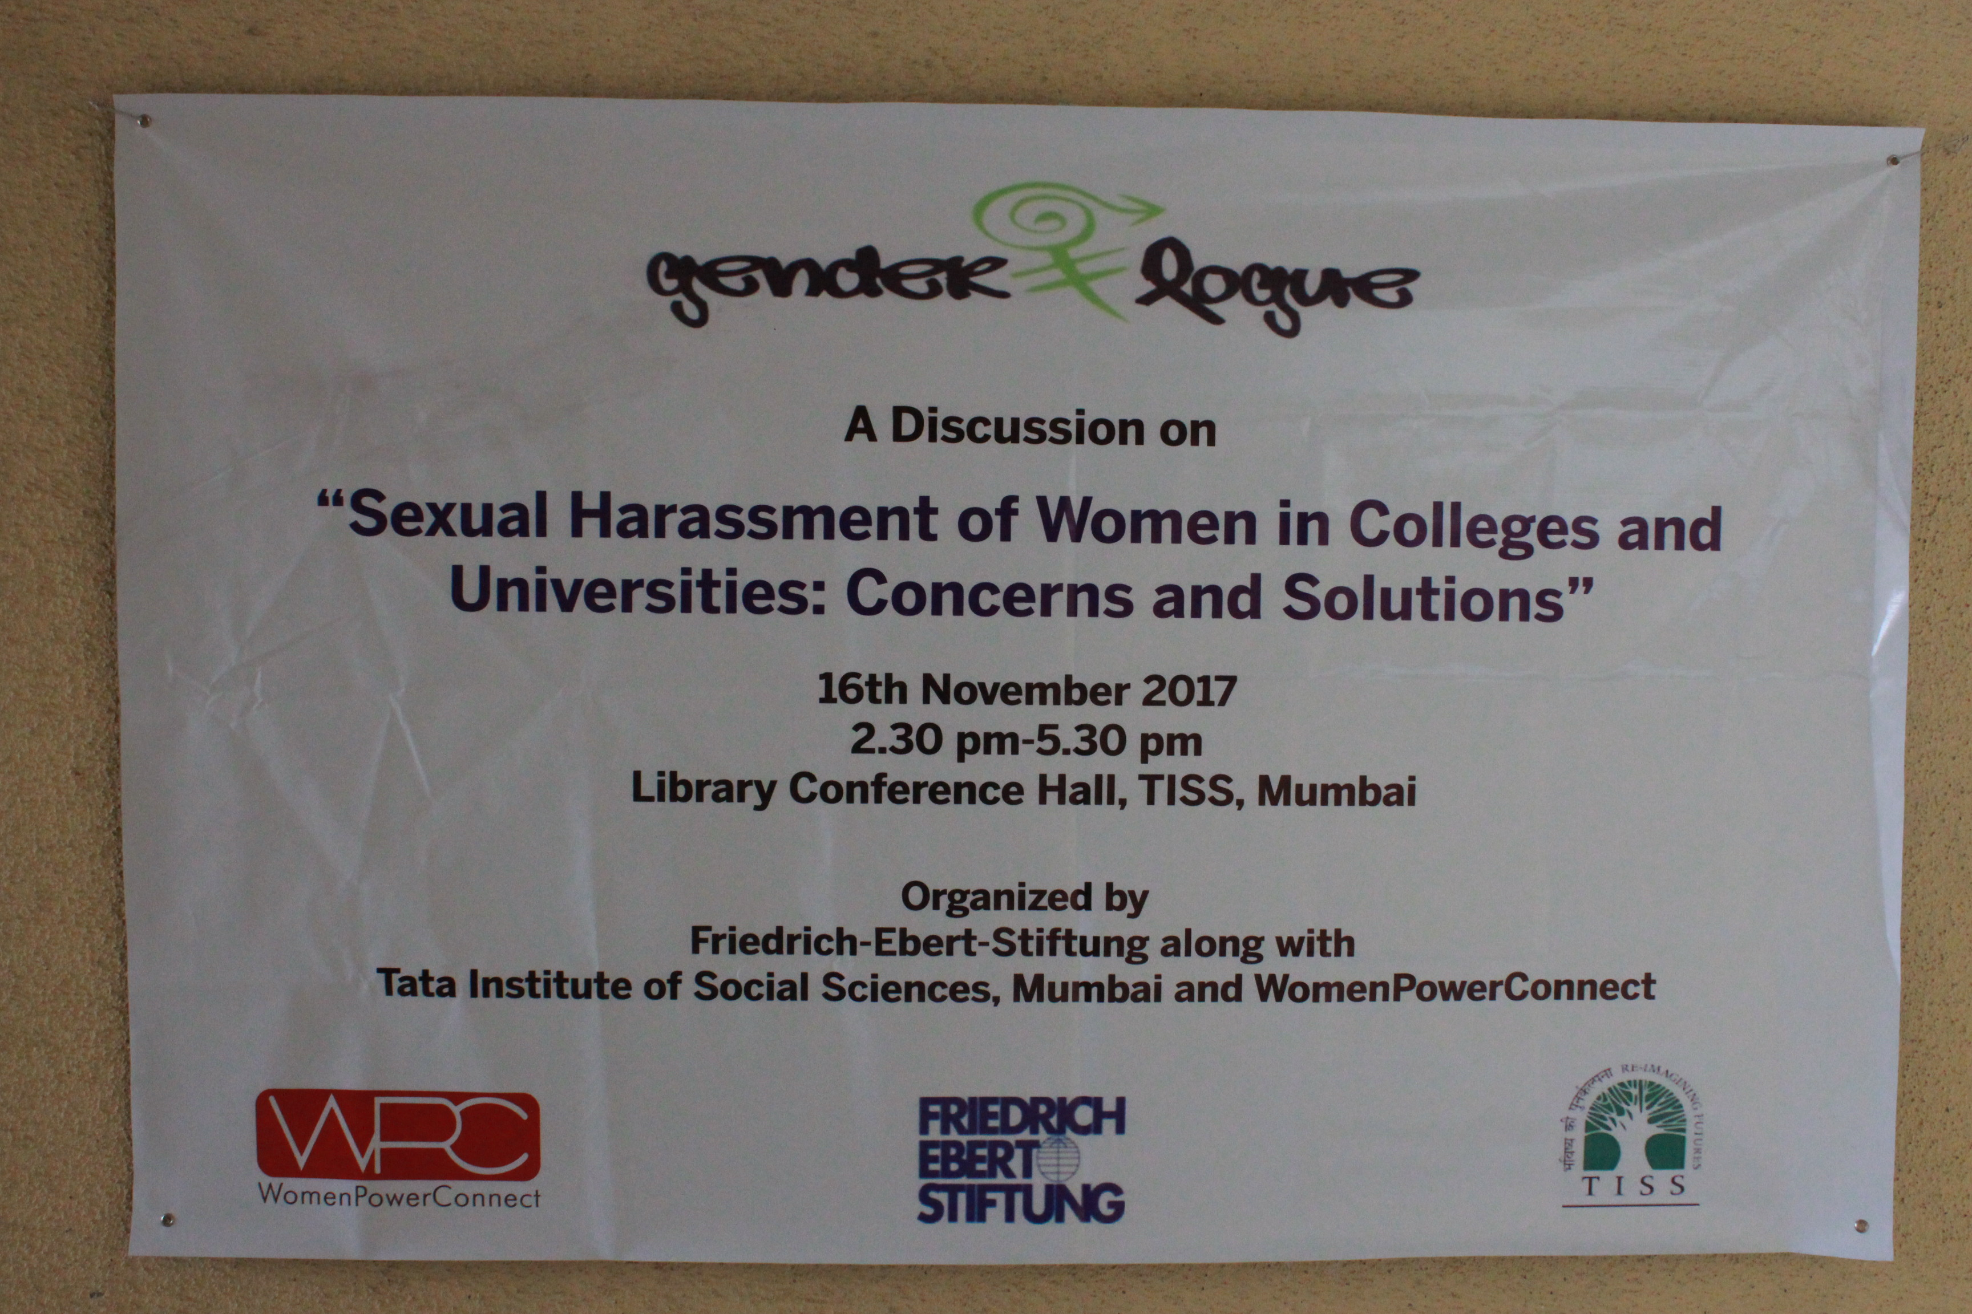

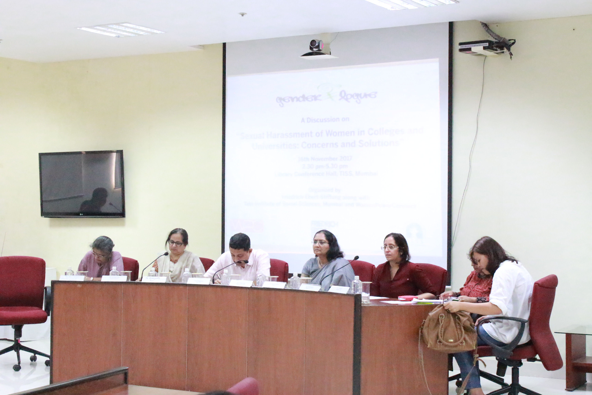

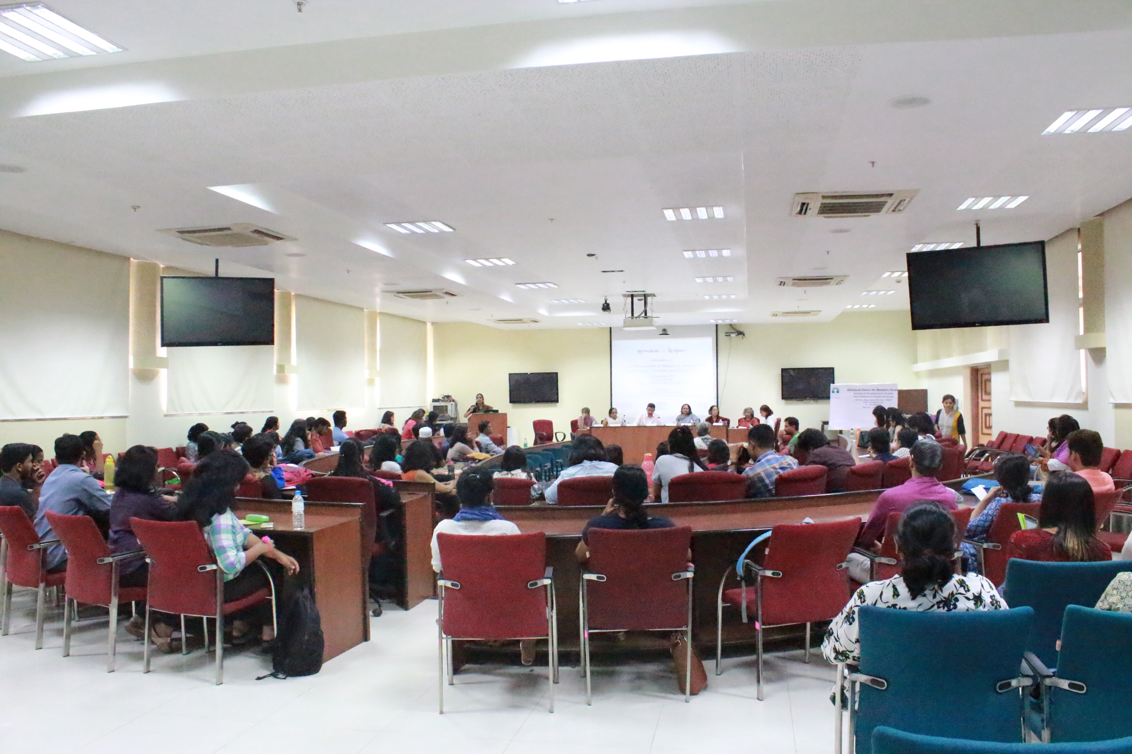

Information accessed at https://www.ugc.ac.in/ugc_notices.aspx?id=1161 on 26/09/2017
Information accessed at https://www.ugc.ac.in/pdfnews/6449649_English.pdf on 26/09/2017
Information accessed at https://www.ugc.ac.in/pdfnews/7203627_UGC_regulations-harassment.pdf on 26/09/2017
Refer to Section 3.1 (d) of the University Grants Commission (Prevention, prohibition and redressal of sexual harassment of women employees and students in higher education institutions) Regulations, 2015.

